My cellular automaton models how simple rules like turn left on red can turn into a beautiful piece of artwork. Cells can be any colour; depending on the design the user has given the program. Squares on a plane are coloured various colors. We define one square as the square the ant is on. This ant can travel in 4 directions, up, down, left and right and turns in these directions according to the rules specified. An example would be:

* At a gray square, turn left and change the colour of the square to red
* At a red square, turn right and change the colour of the square to white
* At a white square, turn left and change the colour of the square to red

These simple rules lead to complex designs. All designs eventually converge and create a “highway”, which is a bridge or extension of the design that will go on forever. In three dimensions this program can even model ant colonies and where there tunnels go.

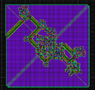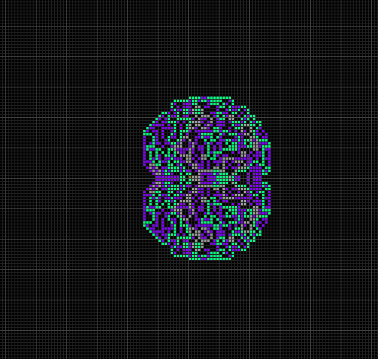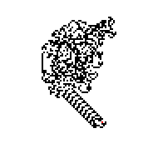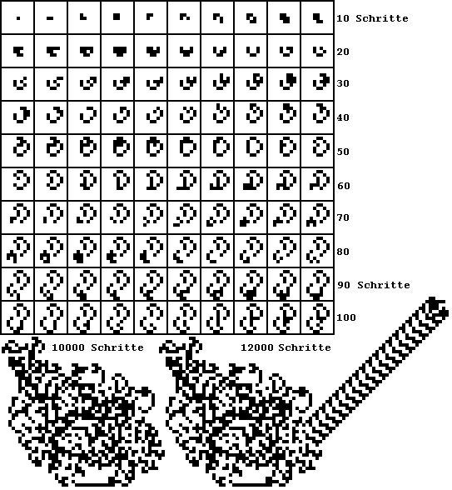

All these are possible designs that it could create. On the left is all the steps of a simple ant from 1-12000 steps. As you can see it has a created a “highway” which is the extension that will never stop.